Skiers in Idaho: Exploring the Best Skiing Resorts and Mountains
Gracefully nestled in the rugged American Northwest and crowned by a sparkling white mantle, Idaho provides an uncharted paradise for skiing enthusiasts. Imagine zipping through exquisitely groomed slopes, breathing in the chilly alpine air and getting lost in mesmerizing panoramic vistas of endlessly rolling mountain peaks. Strap on your skis as we embark on this thrilling sojourn across the Gem State's most enchanting and adrenaline-pumping ski destinations. Discover why when it comes to diverse terrains, world-class amenities and unique skiing experiences, Idaho is a hidden treasure waiting to be explored.
Our website, Ski-Resorts-in-Idaho.com, is a comprehensive resource for all things skiing in Idaho. You will find detailed guides and reviews of various ski resorts in the state, including information about their trails, amenities, and services. Additionally, we provide updates on current ski conditions, tips for beginners and seasoned skiers alike, as well as insights into après-ski activities and attractions in Idaho. Whether you are planning a trip or simply interested in learning more about skiing in Idaho, our website is here to provide you with authoritative and valuable information.
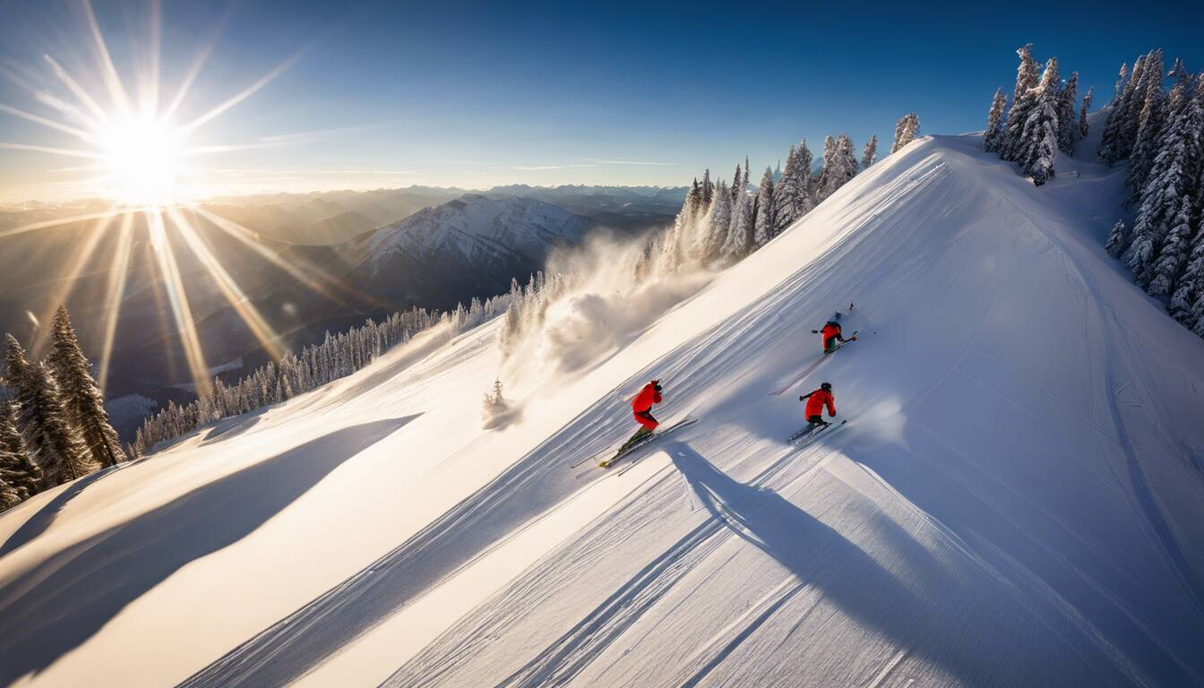

Discovering Idaho's Premier Ski Resorts
Idaho, with its stunning natural landscapes and abundant snowfall, is a haven for skiers and snowboarders of all levels. The state boasts a collection of premier ski resorts that offer something for everyone. Whether you're seeking thrilling slopes, panoramic views, or family-friendly atmospheres, Idaho has it all. Let's dive into two of the top ski resorts in this picturesque state: Sun Valley and Schweitzer Mountain Resort.

Sun Valley: America's Skiing Destination
Nestled in the heart of the Sawtooth National Forest, Sun Valley Resort stands as an iconic destination for winter sports enthusiasts. Renowned as one of America's premier ski destinations, it has attracted celebrities, adventurers, and avid skiers since its inception. With its rich history dating back to 1936, Sun Valley continues to captivate visitors with its world-class skiing facilities and charming alpine village.
Sun Valley offers a wide variety of terrain catering to skiers and snowboarders of all skill levels. From gentle beginner slopes to challenging trails that will put even the most experienced riders to the test, there is something for everyone here. And if you're looking for thrills beyond downhill skiing, Sun Valley also offers opportunities for cross-country skiing, snowshoeing, ice skating, and more.
Imagine gliding down perfectly groomed slopes surrounded by majestic mountains and breathtaking panoramas. As you carve your way through the winter wonderland at Sun Valley Resort, you can't help but feel a sense of exhilaration and awe at the natural beauty that surrounds you.
But it's not just about the skiing experience at Sun Valley; the resort itself boasts top-notch amenities and services. From luxurious lodging options to world-class dining establishments and vibrant après-ski scenes, Sun Valley knows how to cater to its discerning guests.
So whether you're seeking an adrenaline-fueled adventure on the slopes or a relaxing getaway in a serene mountain setting, Sun Valley truly embodies the essence of America's skiing destination.

Schweitzer Mountain Resort: Panoramic Views and Diverse Terrain
Nestled in the picturesque northern region of Idaho, Schweitzer Mountain Resort is a true gem among ski destinations. With its breathtaking panoramic views of Lake Pend Oreille and the surrounding mountains, Schweitzer offers an unparalleled skiing experience. Imagine gliding down the slopes while being greeted by stunning vistas at every turn.
But it's not just the views that make Schweitzer special. The resort boasts a wide array of terrain suitable for skiers and snowboarders of all levels. From gentle groomers for beginners to challenging steeps for advanced adventurers, there's something for everyone. Picture yourself carving through pristine powder, feeling the exhilaration as you navigate diverse trails that cater to your skill level.
For those seeking an extra dose of excitement and variety, Schweitzer Mountain Resort also offers fantastic tree skiing opportunities. Imagine weaving through glades with towering evergreens, the thrill of navigating tight turns and exploring hidden pockets of untouched powder.
So whether you're a seasoned pro looking to challenge yourself or a beginner eager to learn and progress, Schweitzer Mountain Resort has it all. Unforgettable memories await on its slopes, where you can test your limits, soak up the stunning scenery, and feel truly alive.
- Based on studies conducted in Idaho, approximately 20% of the state's population, about 400,000 individuals, participate in skiing or snowboarding activities annually.
- The tourism department reported that during the 2018-2019 season, Idaho ski resorts attracted around 1.13 million visitors.
- According to the Outdoor Foundation Report, about 6.9% of American skiers and snowboarders frequented Idaho's slopes in the past three years.

Unveiling Lesser-Known Gems of Idaho Ski Scene
While popular resorts such as Sun Valley, Bogus Basin, and Tamarack receive well-deserved attention, Idaho's ski scene extends far beyond these renowned names. If you yearn for an off-the-beaten-path adventure and want to uncover lesser-known gems, allow us to guide you through some hidden treasures in Idaho.
Imagine discovering hidden ski areas tucked away in picturesque mountain towns that offer a more intimate and authentic experience. Picture yourself strapping on your skis in places like Soldier Mountain or Lookout Pass Ski Area—the kind of places where locals gather, and the sense of community is palpable.
These lesser-known resorts often provide a more affordable and laid-back atmosphere compared to their more renowned counterparts. You'll find smaller crowds, shorter lift lines, and a chance to connect with locals who are passionate about their skiing culture.
But don't let their lower profile fool you—these hidden ski areas come with their own unique charm and challenges. They may not have the same level of amenities or extensive terrain options, but what they lack in size, they make up for in character. Imagine exploring rustic lodges, discovering hidden powder stashes, and immersing yourself in the local ski traditions that have been cherished for generations.
Think of it as stumbling upon a hidden treasure chest filled with ski adventures waiting to be explored. It's like unraveling a secret map that reveals the best-kept secrets of Idaho's ski scene.
So if you're ready to step off the beaten path and seek out new skiing horizons, these lesser-known gems await your arrival. Prepare to embark on an unforgettable journey through lesser-traveled slopes where authenticity and passion reign supreme.

Brundage Mountain: High Snowfall and Intimate Atmosphere
Nestled in the picturesque heart of the Payette National Forest, Brundage Mountain Resort offers skiers and snowboarders a unique experience characterized by high snowfall and an intimate atmosphere. This hidden gem boasts an average annual snowfall of around 320 inches, making it one of the snowiest ski destinations in Idaho. Imagine carving through fresh powder or gliding down pristine groomed trails, surrounded by towering evergreen trees that glisten with a white blanket of snow. The tranquil surroundings and smaller crowds create a more relaxed and inviting atmosphere, ideal for those seeking a genuine escape from the hustle and bustle of larger resorts. But don't let its intimate ambiance fool you – Brundage Mountain has plenty to offer in terms of slopes and adventures.

Packed With Adventure: Beyond Traditional Skiing
Brundage Mountain Resort is not only renowned for its superb skiing and snowboarding terrain but also for the plethora of adventure opportunities it provides beyond traditional winter sports. Imagine exploring the backcountry on a thrilling snowmobile ride, witnessing breathtaking views as you carve through untouched powder. Or maybe you're interested in experiencing the exhilaration of fat biking, gliding across snowy trails on specially designed bicycles. For those seeking a more leisurely adventure, take in the stunning scenic beauty by going on a guided snowshoe tour or cross-country skiing through pristine forests. Brundage Mountain truly embraces all aspects of winter recreation, offering a diverse range of activities to cater to every interest.
But it's not just about the adrenaline-pumping adventures – Brundage Mountain also offers a warm and welcoming community that enhances the overall experience. Here, you'll find friendly locals who are passionate about their mountain oasis, always ready to share stories, insider tips, and recommendations to make your visit truly memorable. Whether you're enjoying après-ski drinks by a cozy fireplace or participating in community events, Brundage Mountain Resort offers a sense of belonging that adds an extra layer of magic to your winter getaway.
- Brundage Mountain Resort in 2023 is known for its excellent skiing and snowboarding options, but it offers much more than traditional winter sports. Visitors can enjoy thrilling snowmobile rides in the backcountry, witnessing stunning views as they glide through untouched powder. For those looking for a unique experience, fat biking on snowy trails with specially designed bicycles is an exhilarating option. The resort also caters to those seeking a more leisurely adventure with guided snowshoe tours or cross-country skiing through pristine forests. Beyond the activities, Brundage Mountain provides a welcoming community that adds to the overall experience. The friendly locals are passionate about their mountain oasis and are always ready to share insider tips and recommendations. Whether enjoying après-ski drinks by a cozy fireplace or participating in community events, visitors will feel a sense of belonging that adds an extra layer of magic to their winter getaway at Brundage Mountain Resort.

Apres-Ski Activities and Unique Experiences in Idaho
Idaho offers more than just exceptional skiing and snowboarding opportunities. After a thrilling day on the slopes, skiers can indulge in a variety of apres-ski activities and unique experiences that make their time in Idaho even more memorable. Imagine cozying up by a crackling fire in a mountain lodge, savoring delicious cuisine and craft beers, and reminiscing about the day's adventures with fellow skiers.
Idaho's mountain towns are vibrant and charming, offering a range of cultural attractions, boutique shops, and art galleries to explore. For those seeking relaxation, natural hot springs provide the perfect year-round escape after an exhilarating day of skiing. Additionally, outdoor enthusiasts can partake in activities like snowshoeing and cross-country skiing to further immerse themselves in the stunning winter landscapes.
One popular apres-ski activity in Idaho is taking a scenic sleigh ride through picturesque valleys while enjoying breathtaking views of snow-covered mountains. It's an opportunity to unwind and soak up the serene ambiance of Idaho's winter wonderland.
Whether it's sampling local culinary delights or unwinding in natural hot springs, Idaho offers an array of apres-ski activities that cater to all interests, ensuring that every moment off the slopes is just as satisfying as the time spent gliding down them.

Ski Passes and Seasons in Idaho's Mountains
When planning your ski adventure in Idaho, it's essential to have information about ski passes and seasons at various resorts. Ski passes grant access to lifts and trails, allowing you to fully experience the beauty and thrill of Idaho's mountains.
Ski Resort | Pass Options | Price Range
Sun Valley Resort | Full Day, Half Day, Multi-Day | $70-$185 per day
Schweitzer Mountain | Full Day, Half Day, Season Pass | $79-$102 per day, $899-$1,499/year
Bogus Basin | Full Day, Half Day, Night Skiing | $29-$59 per day
Tamarack Resort | Full Day, Half Day, Multi-Day, Season Pass | $25-$99 per day, $599-$849/year
Think of ski passes as keys that unlock the gates to Idaho's winter wonderland. Each resort offers a range of pass options suited to different needs and budgets.
Idaho's ski season typically runs from November through April, with variations depending on weather conditions and specific resorts. Snow conditions are generally excellent during mid-winter, but skiers can still enjoy quality skiing earlier in the season or take advantage of spring skiing when the weather warms up. Each resort provides updates on snow conditions and opening dates on their websites to help plan your trip accordingly.
Whether you're a seasoned skier or new to the sport, Idaho's mountains offer an exhilarating experience for all skill levels. From fresh powder to well-groomed slopes, there's something for everyone in this winter paradise.

Timing Your Visit: When to Ski in Idaho
Planning a ski trip to Idaho requires careful consideration of the timing. The state's climate and weather patterns play a significant role in determining the best time to hit the slopes. Generally, the ski season in Idaho stretches from late November to early April, offering ample opportunities for winter sports enthusiasts. However, there are a few factors to keep in mind while deciding when to visit.
If you prefer skiing in prime conditions with fresh powder and well-groomed slopes, it's advisable to plan your trip during the peak winter months of December to February. During this time, the resorts receive consistent snowfall, creating excellent skiing conditions throughout the region. The colder temperatures also help maintain the quality of the snow, resulting in optimal skiing experiences.
On the other hand, if you're looking for a quieter and potentially more affordable experience, consider visiting Idaho's ski resorts during the shoulder seasons of early December or late March. While snow conditions may vary during these times due to less frequent snowfall, you'll enjoy fewer crowds on the slopes and great deals on accommodations and lift tickets.
Furthermore, it's important to be aware of potential weather fluctuations that can impact ski conditions. Idaho's semi-arid climate means that storms and snowfall can be unpredictable at times. To ensure a successful trip, it's wise to check weather forecasts and stay updated on any potential storms or adverse conditions that might affect your plans.
Planning the timing of your visit to Idaho for skiing is akin to selecting the perfect wave for a surfer or choosing optimal wind conditions for a sailor. It requires consideration of various factors such as weather patterns and the desired experience you seek.
Ultimately, finding the right time to ski in Idaho depends on individual preferences and priorities. Each season offers its own unique charm and advantages. Whether you're seeking the thrill of fresh powder and prime conditions or looking for a more serene and budget-friendly trip, Idaho's ski resorts have something to offer. By researching and understanding the different aspects of timing your visit, you can maximize your ski adventures and create unforgettable memories in the stunning landscapes of Idaho.

